SPRINT 3

|  |  |
| --- | --- |
| Date | 12 November 2022 |
| Team ID | PNT2022TMID33811 |
| Project Name | Project – Smart Farmer-IoT Enabled smart Farming Application |

Creating Mobile app using MIT app Inventor SMART FARMER APPLICATION

App Inventor + IoT can work together to help us understand, and change, our everyday lives.

Login Page:

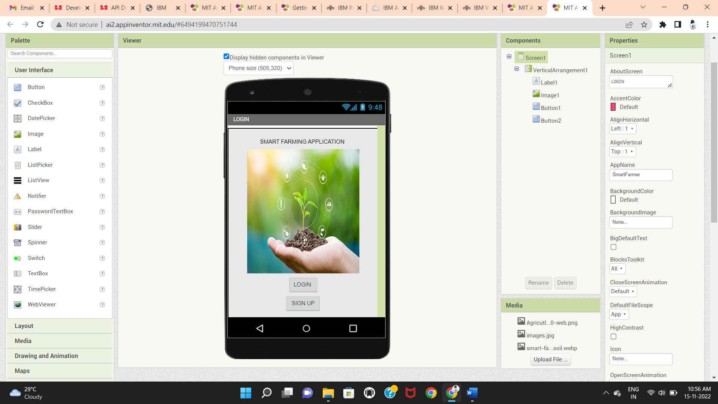

Blocks:

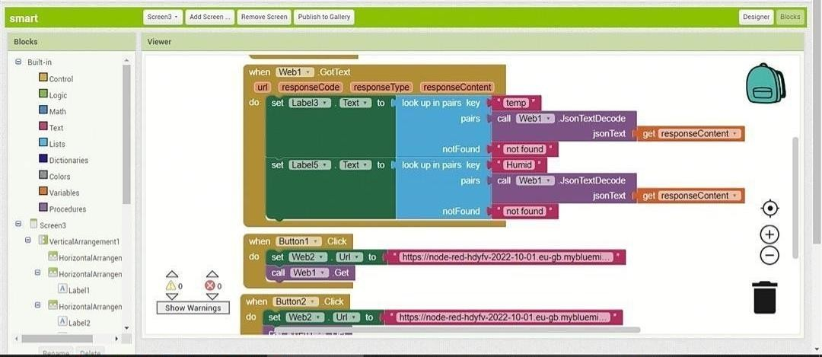

QR Code for APK download:

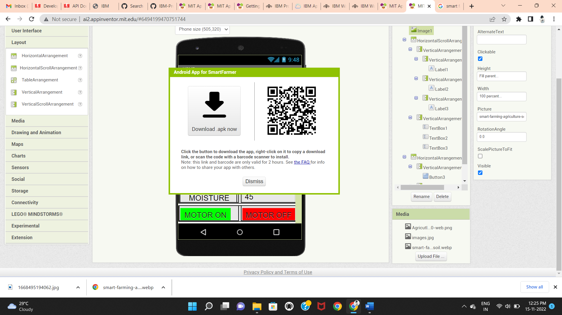

Output Screen in Mobile :

